**Experiment 9:  
Q1:  
Code:  
XML Code:**

<?xml version="1.0" encoding="utf-8"?>

<RelativeLayout xmlns:android="http://schemas.android.com/apk/res/android"

xmlns:tools="http://schemas.android.com/tools"

android:layout_width="match_parent"

android:layout_height="match_parent"

tools:context=".MainActivity">

<ToggleButton

android:id="@+id/toggleButton"

android:layout_width="wrap_content"

android:layout_height="wrap_content"

android:text="Bluetooth"

android:textOn="Bluetooth ON"

android:textOff="Bluetooth OFF"

android:checked="false"

android:layout_centerInParent="true" />

</RelativeLayout> **MainActivity.java:**

package com.example.experiment_9_1;

import androidx.appcompat.app.AppCompatActivity;

import android.os.Bundle;

import android.widget.ArrayAdapter;

import android.widget.AutoCompleteTextView;

import android.widget.ToggleButton;

public class MainActivity extends AppCompatActivity {

ToggleButton tb1;

@Override

protected void onCreate(Bundle savedInstanceState) {

super.onCreate(savedInstanceState);

setContentView(R.layout.activity_main);

}

****} **Output:**

**Q2:**

**Code:  
XML Code:**

<?xml version="1.0" encoding="utf-8"?>

<TableLayout xmlns:android="http://schemas.android.com/apk/res/android"

xmlns:app="http://schemas.android.com/apk/res-auto"

xmlns:tools="http://schemas.android.com/tools"

android:layout_width="match_parent"

android:layout_height="match_parent"

tools:context=".MainActivity">

<TableRow

android:layout_width="match_parent"

android:layout_height="match_parent">

<TextView

android:layout_width="wrap_content"

android:layout_height="wrap_content"

android:layout_marginLeft="80dp"

android:layout_marginTop="80dp"

android:text="Number 1" />

<EditText

android:layout_width="100dp"

android:layout_height="wrap_content"

android:layout_marginLeft="40dp"

android:id="@+id/n1"

android:layout_marginTop="80dp"

/>

</TableRow>

<TableRow

android:layout_width="match_parent"

android:layout_height="match_parent">

<TextView

android:layout_width="wrap_content"

android:layout_height="wrap_content"

android:layout_marginLeft="80dp"

android:layout_marginTop="20dp"

android:text="Number 2" />

<EditText

android:layout_width="100dp"

android:layout_height="wrap_content"

android:layout_marginLeft="40dp"

android:id="@+id/n2"

android:layout_marginTop="20dp"

/>

</TableRow>

<TableRow

android:layout_width="match_parent"

android:layout_height="match_parent">

<TextView

android:layout_width="wrap_content"

android:layout_height="wrap_content"

android:layout_marginLeft="80dp"

android:layout_marginTop="20dp"

android:text="Result" />

<EditText

android:layout_width="100dp"

android:layout_height="wrap_content"

android:layout_marginLeft="40dp"

android:id="@+id/res"

android:layout_marginTop="20dp"

/>

</TableRow>

<TableRow>

<Button android:layout_width="110dp"

android:layout_height="wrap_content"

android:layout_marginLeft="80dp"

android:layout_marginTop="60dp"

android:id="@+id/add"

android:text="Addition"

/>

<Button android:layout_width="125dp"

android:layout_height="wrap_content"

android:layout_marginLeft="30dp"

android:layout_marginTop="58dp"

android:id="@+id/sub"

android:text="Subrtaction"

/>

</TableRow>

<TableRow

android:layout_width="match_parent"

android:layout_height="match_parent">

<Button

android:id="@+id/mul"

android:layout_width="130dp"

android:layout_height="wrap_content"

android:layout_marginLeft="70dp"

android:layout_marginTop="60dp"

android:text="Multiplication" />

<Button

android:id="@+id/div"

android:layout_width="125dp"

android:layout_height="wrap_content"

android:layout_marginLeft="30dp"

android:layout_marginTop="58dp"

android:text="Divide" />

</TableRow>

</TableLayout>

**MainActivity.java:**

package com.example.experiment_9_2;

import androidx.appcompat.app.AppCompatActivity;

import android.os.Bundle;

import android.view.View;

import android.widget.Button;

import android.widget.EditText;

public class MainActivity extends AppCompatActivity {

EditText n1, n2, result;

Button add, sub, mul, div;

@Override

protected void onCreate(Bundle savedInstanceState) {

super.onCreate(savedInstanceState);

setContentView(R.layout.activity_main);

n1 = findViewById(R.id.n1);

n2 = findViewById(R.id.n2);

result = findViewById(R.id.res);

add = findViewById(R.id.add);

sub = findViewById(R.id.sub);

mul = findViewById(R.id.mul);

div = findViewById(R.id.div);

add.setOnClickListener(new View.OnClickListener() {

@Override

public void onClick(View v) {

int sum = Integer.parseInt(n1.getText().toString()) + Integer.parseInt(n2.getText().toString());

result.setText(Integer.toString(sum));

}

});

sub.setOnClickListener(new View.OnClickListener() {

@Override

public void onClick(View v) {

int sub = Integer.parseInt(n1.getText().toString()) - Integer.parseInt(n2.getText().toString());

result.setText(Integer.toString(sub));

}

});

mul.setOnClickListener(new View.OnClickListener() {

@Override

public void onClick(View v) {

int mul = Integer.parseInt(n1.getText().toString()) * Integer.parseInt(n2.getText().toString());

result.setText(Integer.toString(mul));

}

});

div.setOnClickListener(new View.OnClickListener() {

@Override

public void onClick(View v) {

int div = Integer.parseInt(n1.getText().toString()) / Integer.parseInt(n2.getText().toString());

result.setText(Integer.toString(div));

}

});

}

}

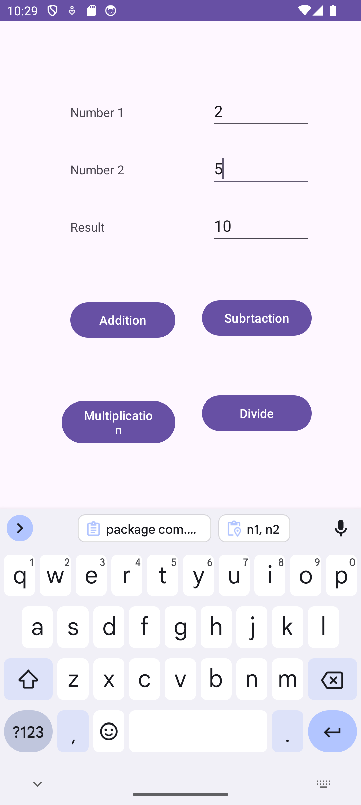**Output:**